**Design of Police Safety System**

The project is based on police safety to check drunken driving. This has turned into a major challenge for police especially during this pandemic situation. Inorder to avoid this kind of situation, a simple movable kiosk (booth) having an alcohol detector inside is built using Arduino UNO.

* **Design**

The main components required here are Arduino UNO, ultrasonic sensor and gas sensor.The trigger and echo pins of Ultrasonic sensor are connected to digital pin no. 8 and 9 of arduino.

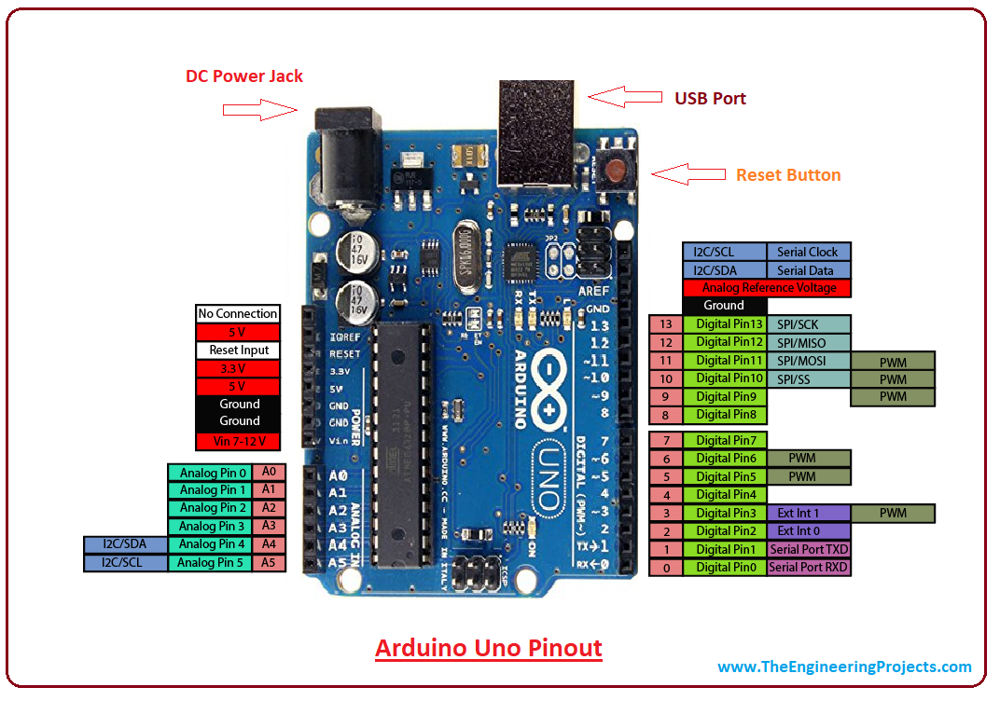

The power and ground of sensor are connected to 5V and ground respectively on breadboard.

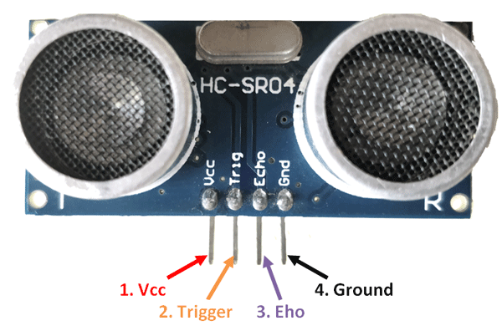

B1, H2 and B2 of gas sensor is connected to 5V while H1 and A2 is connected to ground. A1 of gas sensor is connected to analog pin A5 of Arduino UNO. DB7, DB6, DB5, DB4 and Enable pin of LCD display is connected to A4, A3, A2, A1 and A0 of Arduino UNO. The contrast pin of display is connected to Wiper of potentiometer. The display is powered with 5V with backlight ON.

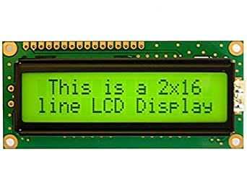

Three types of led are used. Green led to pin no.5, white led to pin no. 3 and series of 6 red leds to 6, 7,10,11,12 and 13 of Arduino UNO. It can be connected to any of the digital pins.

Piezo buzzer is connected to digital pin no. 4 of Arduino board.

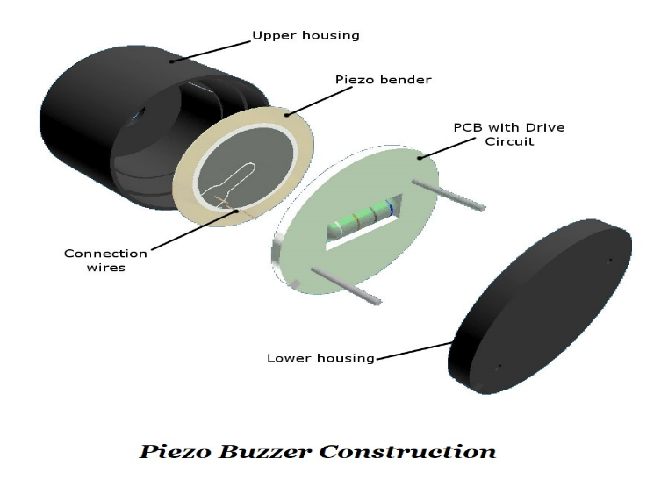

* **Working**

When a person aproaches near the booth (here considered distance is 10cm), white light is turned on. When the distance of face is greater than 5 cm and less than 10 cm, message is displayed on LCD display to step closer and wait for green light. When distance of face is equal to 5cm, green light turns on with a beep sound. The alcohol meter is ready to measure the intensity. The person is ready to blow to the alcohol meter. It consists of gas sensor. The least value it can measure is 20. For analog input value (A0) greater than 20 and less than equal to 25, first red led is on. For analog Read value greater than 25 and less than equal to 40, second led turns on. Analog value A0 greater than 40 and lesser than equal to 60, third led turns on. Analog value A0 greater than 60 and lesser than equal to 80, fourth led turns on. Analog value A0 greater than 80 and lesser than equal to 100, fifth led turns on. Analog value A0 greater than 100, all the led s turn on. Below are the different levels of alcohol consumption in the range of 0-10.

Level 1 - 20 to 25 - Intensity LOW

Level 2 - 25 to 30 - Intensity LOW

Level 3 - 30 to 40 - Intensity LOW

Level 4 - 40 to 50 - Intensity MEDIUM

Level 5 - 50 to 60 - Intensity MEDIUM

Level 6 - 60 to 70 - Intensity MEDIUM

Level 7 - 70 to 80 - Intensity HIGH

Level 8 - 80 to 90 - Intensity HIGH

Level 9 - 90 to 100 - Intensity HIGH

Level 10 - greater than 100- Intensity HIGH (Alert)

* **Real life implementation**

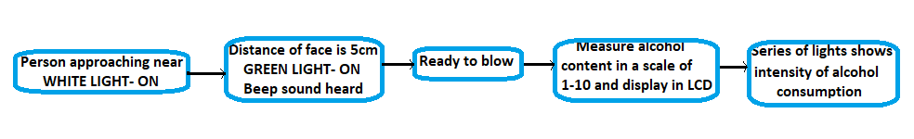

This automatic kiosk is very helpful because alcohol content can be found with least physical contact. This will definitely be helpful for police especially during the pandemic time where there is a threat of coronavirus spread. Police can easily get to know the exact alcohol consumption without physical contact with the person. Thus necessary measures can be taken in advance, road accidents can be reduced.

The implementation is simple and efficient. The entire setup requires Arduino UNO, ultrasonic sensor, gas sensor, buzzer, LCD display and few led lights which is available at minimum cost. With the help of relays, led or fluorescent bulb can be operated in place of led s.All these components are widely available in the market. Proper arrangements of components is important. This design can be placed in a simple movable kiosk which has the ability of flexibility. It can be moved from one place to another with ease. Thus testing can be done more efficiently.

By proper placement of these kiosks in cities or in highways, maximum advantage could be obtained. Ultrasonic sensor SR04 is able to detect even small changes in distance which uses SONAR to detect distance. By setting the proper distance, one can be allowed to blow. As mentioned above, instead of led s , appropriate bulbs could be used. Necessary instructions can be displayed on the LCD (which is placed at the top of kiosk) so that there won't be any confusions regarding the usage of this alcohol detector. The MQ-2 Gas Sensor module is useful for gas leakage detecting in home and industry. It can detect LPG, i-butane, propane, methane, alcohol, hydrogen and smoke. This gives instantaneous alcohol content in air and displays the intensity and level in LCD display. This design can also be used in fire alarm detection in house and factories, automatic alcohol detection in vehicles etc.